How I Made a World Cup 2026 Dashboard.
I am not a football fanatic. I don't follow league standings during the season, I don't have a club I support every week, and most of the time I only catch scores in passing.
Even during this World Cup, I only watched two full matches, including the final.
I wanted a simple portal: what the bracket looks like, which players are on which squad, who's leading each group, who's the top scorer, and so on. It didn't need to be complicated.
The official FIFA site doesn't make that easy. The site presents information that's too complex. To find one simple answer, I had to click through several layers of navigation.
(https://www.fifa.com/en/tournaments/mens/worldcup/canadamexicousa2026/)
So I tried building my own portal to show information about the World Cup 2026 matches.
wc2026 is a small wall chart: 12 groups and their standings, the knockout bracket from the Round of 32 to the final, the Golden Boot race, and full squads for all 48 teams. That's it. No news feed, no betting odds — just the structure of the tournament, kept current.
Two more things got added once the tournament was actually underway. Every fixture has a link to a full-match highlight video, pulled from FolaPlay's YouTube channel and matched automatically to the right game. And every day, the app generated its own predictions — who'd win each match, a Golden Boot projection, and a champion forecast — using Claude, with OpenRouter as an automatic fallback.
The whole thing runs on a Next.js frontend and a FastAPI backend, with PostgreSQL as the database. The tournament structure — groups, fixtures, squads — is seeded once from a wall-chart spreadsheet. From there, an hourly background job pulls live scores and match status from ESPN's public scoreboard, which doesn't require an API key. If that job fails, the site just keeps showing the last valid data instead of erroring out.
The frontend pages are server-rendered and cached for five minutes, so the site stays fast without hammering the API every time someone opens a page.
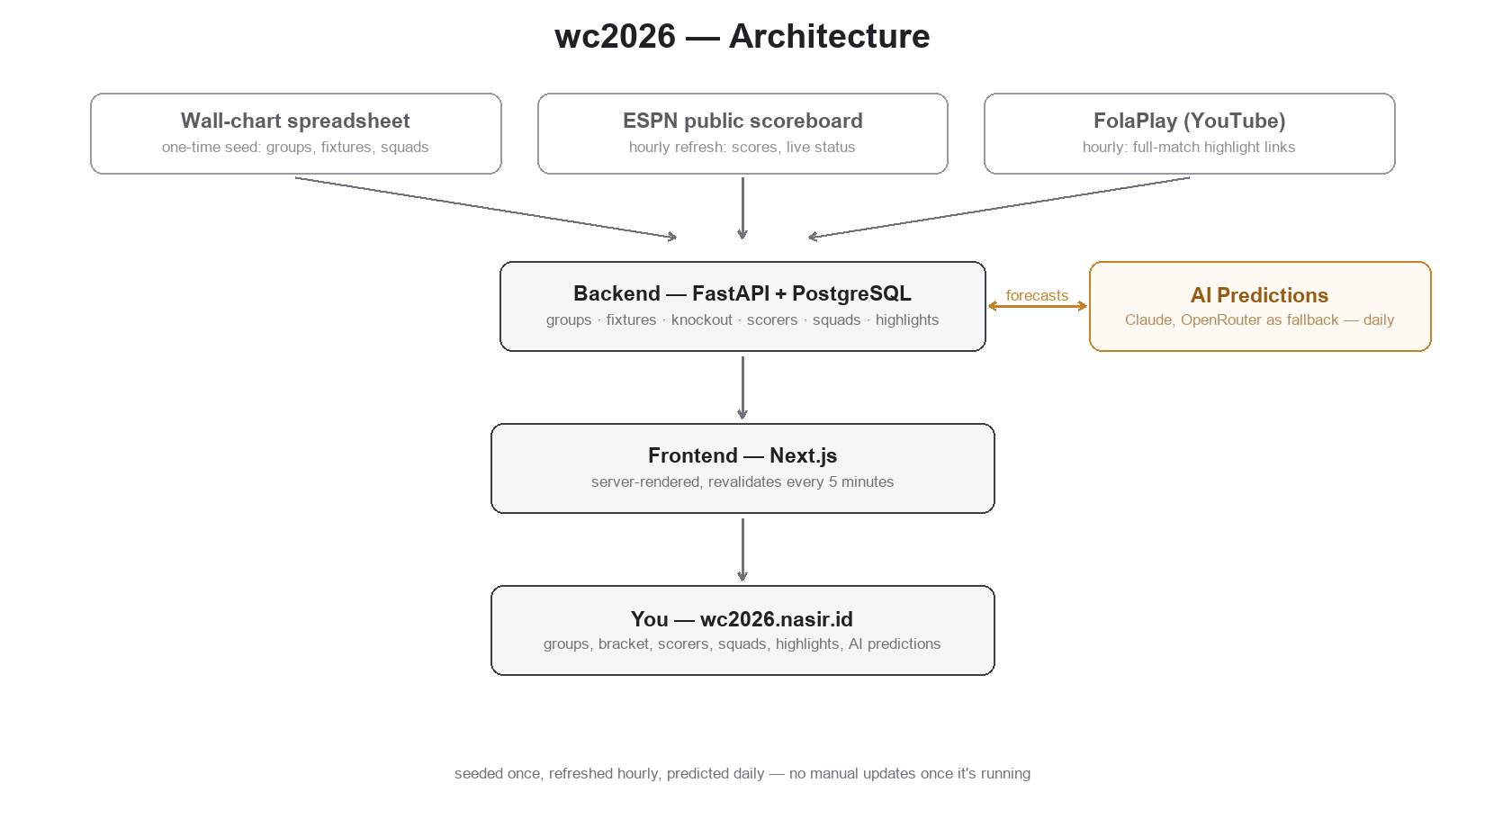
How wc2026 stays up to date, end to end.
I'm a Messi fan, and by extension an Argentina fan. I watched the final hoping they'd win.
But honestly, Spain deserved to win. They outclassed every team they played, in every phase of the game — build-up, pressing, finishing.
wc2026.nasir.id is still accessible if you want to see the complete World Cup 2026 information.

